1. Write a program to calculate the Simple Interest with minimal code using features of

Java 11.

Hint: Use the concept of functional interface and Local variable syntax for lambda

parameters.

**Code:**

interface *SimpleInterest*{  
 public double Si(int principal,int time,double rate);  
}  
  
public class Assignment4Q1 {  
 public static void main(String[] args) {  
 *SimpleInterest* simpleInterest = ((principal, time, rate) -> (principal*time*rate)/100 );  
  
 System.out.println("Simple Interest\nPrincipal = 1000\nRate of interest = 6.5\nTime = 4");  
 System.out.println("Simple interest = "+simpleInterest.Si(1000,4,6.5));  
  
 *//not required* double amount = 1000+simpleInterest.Si(1000,4,6.5);  
 System.out.println("Total Amount = "+amount);  
 }  
}

Output:

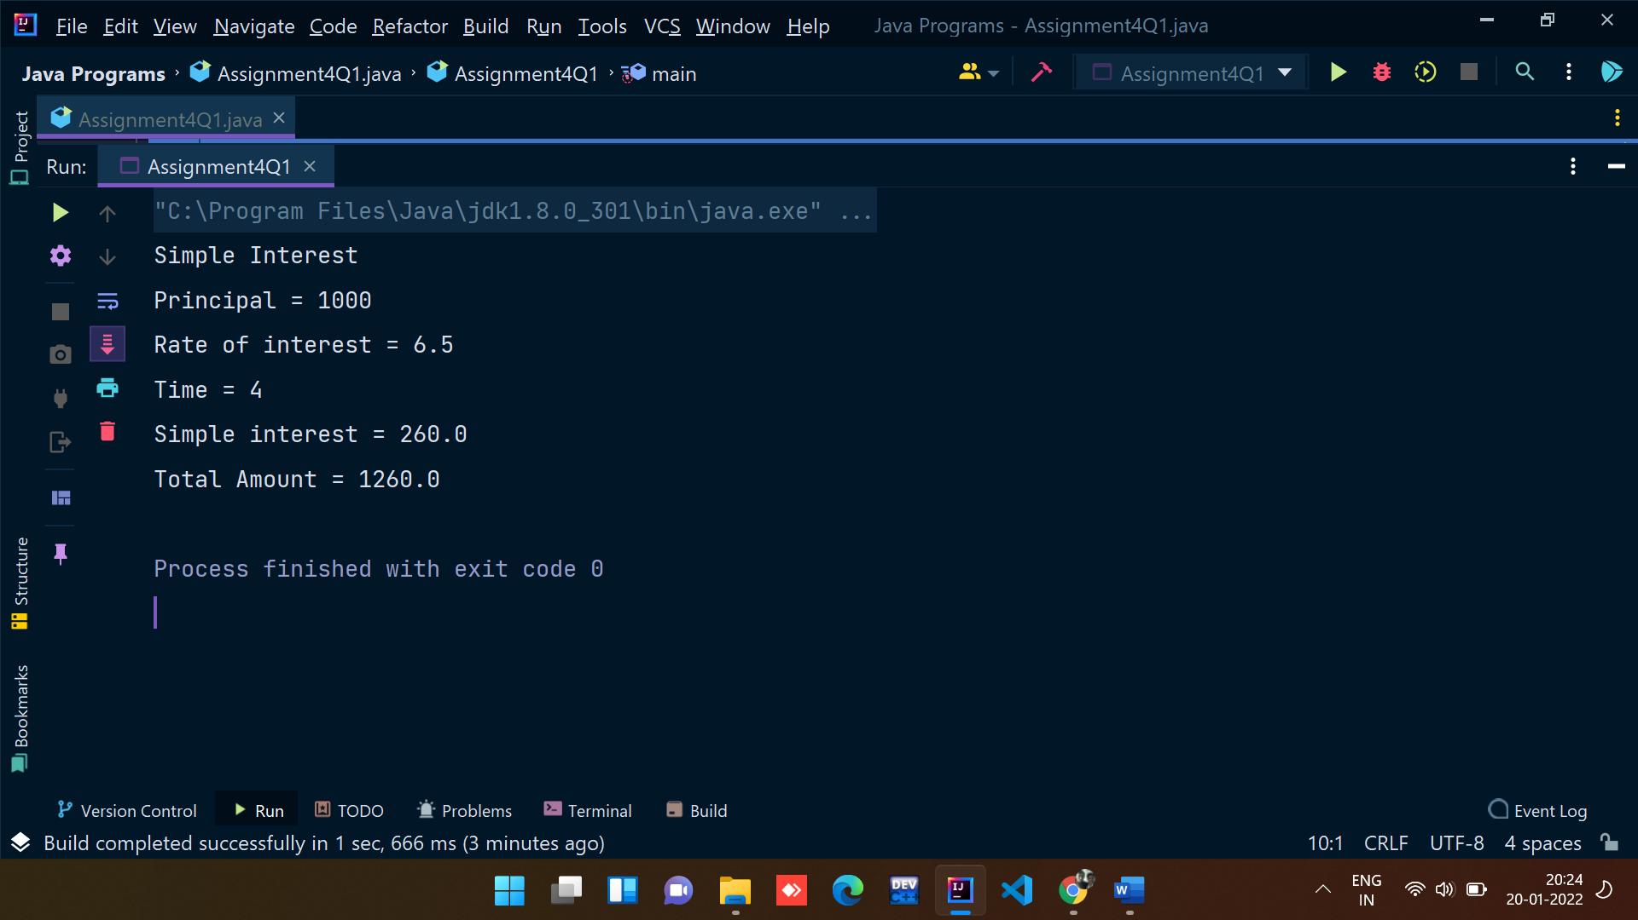

2. Java 11 supports var keyword for variable declarations. List the scenarios where var

keyword cannot be used for such variable declarations. Give reason in support of

your answer for each scenario.

**Answer:**

* You can use var only for local variables (in methods). It cannot be used for instance variables (at class level).
* You cannot use var in Lambda expressions.
* You cannot use var for method signatures (in return types and parameters).

And remember, you cannot use var to declare a variable without explicit initialization, hence the following:

var x;

is not allowed, since local variable declaration requires initialization on the right side. That also means this declaration is not valid:

var x = null;

3. “A quick brown fox jumps over the lazy dog”. Create an ArrayList from the given

String. Such an ArrayList should include each word from the given sentence. Finally

convert such List to an array using Java 11 methods and print the output.

**Code:**

import java.util.ArrayList;  
  
*//A quick brown fox jumps over the lazy dog.*public class Assignment4Q3 {  
 public static void main(String[] args) {  
 ArrayList<String> arrayList = new ArrayList<String>();  
 arrayList.add("A");  
 arrayList.add("quick");  
 arrayList.add("brown");  
 arrayList.add("fox");  
 arrayList.add("jumps");  
 arrayList.add("over");  
 arrayList.add("the");  
 arrayList.add("lazy");  
 arrayList.add("dog");  
  
 *//converting array list to array* Object[] objects = arrayList.toArray();  
  
 for (Object obj: objects){  
 System.out.print(obj+" ");  
 }  
 }  
}

**Output:**